Synopsis

Loan Default Prediction using Machine Learning
Problem Id: 2

Krishna Mandal
2028447
Section-L

Mansha Khati
2028452
Section-L

Samriddhi Agarwal
2028482
Section-L

\

- Problem Description
In the banking sector, one of the major challenges is deciding whether a customer is likely to repay a loan or not. Financial institutions deal with large volumes of loan applications, and even a small percentage of wrong decisions can result in significant losses. Because of this, there is a strong need for a system that can assist in identifying risky customers before approving loans.
In this project, we aim to build a machine learning-based classification system using a real-world loan dataset (such as Lending Club data). The dataset contains various customer and loan-related features such as loan amount, interest rate, employment details, credit history, and repayment behavior. These features provide useful information about the financial condition of a borrower.
The goal of this project is to analyze these features and develop a model that can classify whether a loan will be fully paid or defaulted. This system can help banks in reducing risk, improving decision-making speed, and making the loan approval process more reliable.

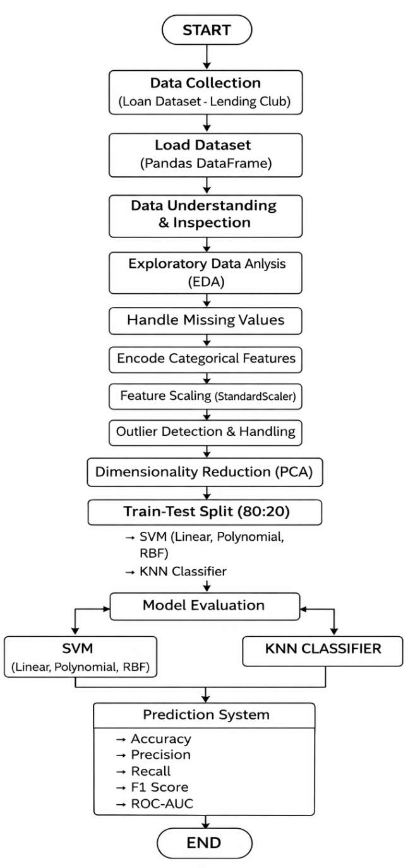
- Steps of Implementation (ML Pipeline)

Feature Name | Description | Data Type
loan_amnt | Amount of loan applied by customer | Numerical (int)
funded_amnt | Amount funded by lender | Numerical (int)
term | Loan duration (36 or 60 months) | Categorical
int_rate | Interest rate of loan | Numerical (float)
installment | Monthly payment amount | Numerical (float)
grade | Loan grade assigned by company | Categorical
sub_grade | Sub category of loan grade | Categorical
emp_title | Job title of borrower | Categorical
emp_length | Employment duration | Categorical
home_ownership | Ownership status (Rent/Mortgage/Own) | Categorical
annual_inc | Annual income of borrower | Numerical (float)
verification_status | Income verification status | Categorical
loan_status | Target variable (Default / Fully Paid) | Categorical
purpose | Purpose of loan | Categorical
dti | Debt-to-income ratio | Numerical (float)
delinq_2yrs | Number of delinquencies in last 2 years | Numerical (int)
fico_range_low | Lower range of FICO score | Numerical (int)
fico_range_high | Upper range of FICO score | Numerical (int)
open_acc | Number of open credit accounts | Numerical (int)
pub_rec | Number of public records | Numerical (int)

1.Data Collection
The dataset used in this project is obtained from platforms such as Kaggle or Lending Club, which provide real-world financial datasets.
- The dataset contains borrower-related attributes such as:
  - Loan Amount
  - Annual Income
  - Credit History
  - Interest Rate
  - Employment Details
- The target variable represents whether a loan is defaulted (1) or not (0).
- The dataset is stored in CSV format and loaded into Python using Pandas.

2. Data Loading and Initial Inspection
The dataset is loaded into a DataFrame for analysis:

df = pd.read_csv("loan_data.csv")

3. Exploratory Data Analysis (EDA)
EDA is performed to understand patterns and relationships between features.
Visualization Techniques Used:
- Histogram → distribution of loan amount
- Correlation heatmap → relationship between features

plt.hist(df["LoanAmount"])
plt.show()

Using Matplotlib:
- Identify skewness in features
- Detect important variables affecting loan default
Outcome:
- Recognized feature importance
- Observed relationships between variables
- Prepared insights for preprocessing

4. Data Preprocessing
This step transforms raw data into a format suitable for machine learning.
Handling Missing Values

df.fillna(0, inplace=True)

- Missing values replaced using statistical or default values

Feature Selection (Numerical Data Only)

X = df.select_dtypes(include=np.number)

- Only numerical features selected for compatibility

Feature Scaling
Standardization is applied using:

from sklearn.preprocessing import StandardScaler
scaler = StandardScaler()
X_scaled = scaler.fit_transform(X)

- Ensures all features are on same scale
- Improves performance of distance-based models

Outcome:
- Clean dataset
- Scaled and normalized features
- Ready for model training

5. Train-Test Split
The dataset is divided into training and testing sets:

from sklearn.model_selection import train_test_split
X_train, X_test, y_train, y_test = train_test_split(X_scaled, y, test_size=0.2)

- 80% Training Data → model learning
- 20% Testing Data → evaluation

6. Dimensionality Reduction (PCA)
Principal Component Analysis is applied to reduce feature space:

from sklearn.decomposition import PCA
pca = PCA(n_components=0.95)
X_train_pca = pca.fit_transform(X_train)
X_test_pca = pca.transform(X_test)

- Retains 95% variance
- Reduces dimensionality
- Helps in:
  - Faster computation
  - Reducing overfitting

7. Model Training
Multiple classification models are implemented:

Support Vector Machine (SVM)
Using scikit-learn:
- Linear Kernel
- Polynomial Kernel
- RBF Kernel

from sklearn.svm import SVC
model = SVC(kernel='rbf')
model.fit(X_train_pca, y_train)

K-Nearest Neighbors (KNN)

from sklearn.neighbors import KNeighborsClassifier
knn = KNeighborsClassifier(n_neighbors=5)
knn.fit(X_train_pca, y_train)

Outcome:
- Models trained on processed dataset
- Ready for evaluation

8. Model Evaluation
Models are evaluated using classification metrics:

from sklearn.metrics import classification_report

Metrics Used:
- Accuracy
- Precision
- Recall
- F1 Score
- ROC-AUC
- A classification report is generated for detailed analysis

9. Model Comparison
- Accuracy scores of all models are compared
- Visualization is done using bar graph:

plt.bar(models, scores)
plt.show()

Outcome:
- Visual comparison of performance
- Identification of best model

10. Result Analysis
- Among all models, SVM with RBF kernel performs best
- Provides:
  - Balanced Precision & Recall
  - Higher ROC-AUC score
Final Conclusion:
- PCA + SVM (RBF) gives optimal performance
- Model effectively predicts loan default

Output analysis-
This section contains all graphs and output visualizations used in the project.

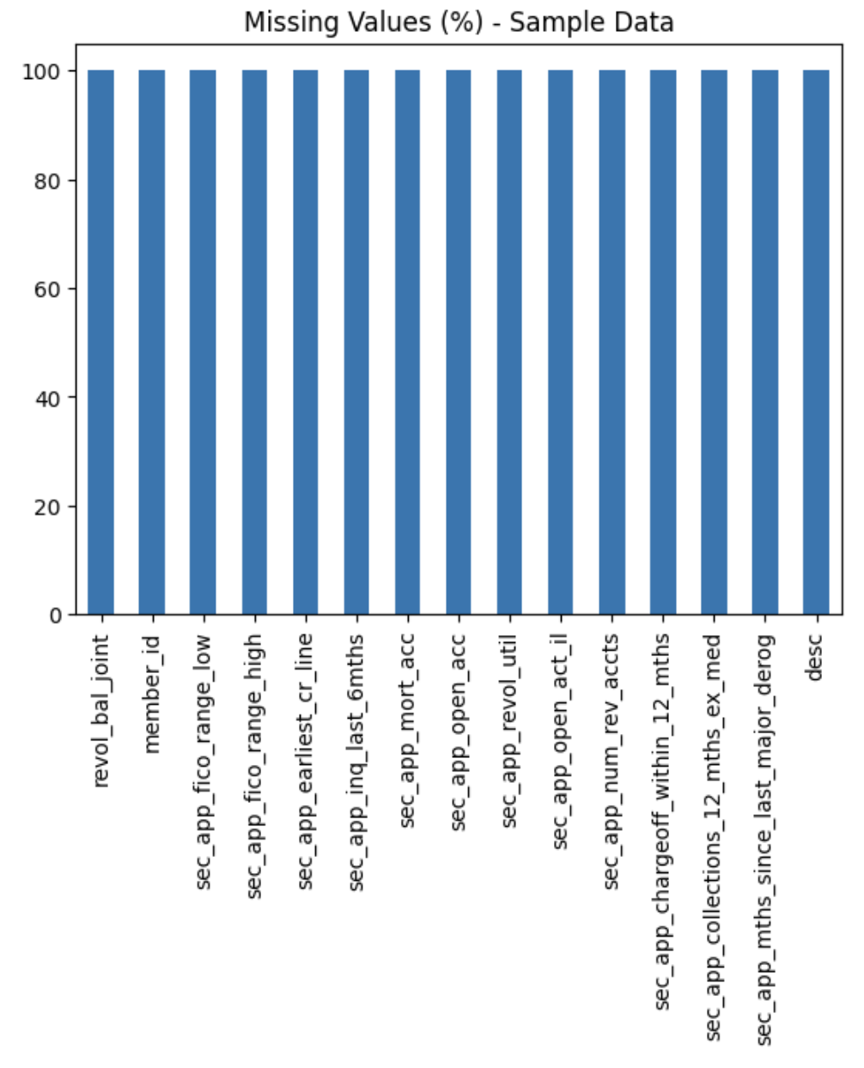

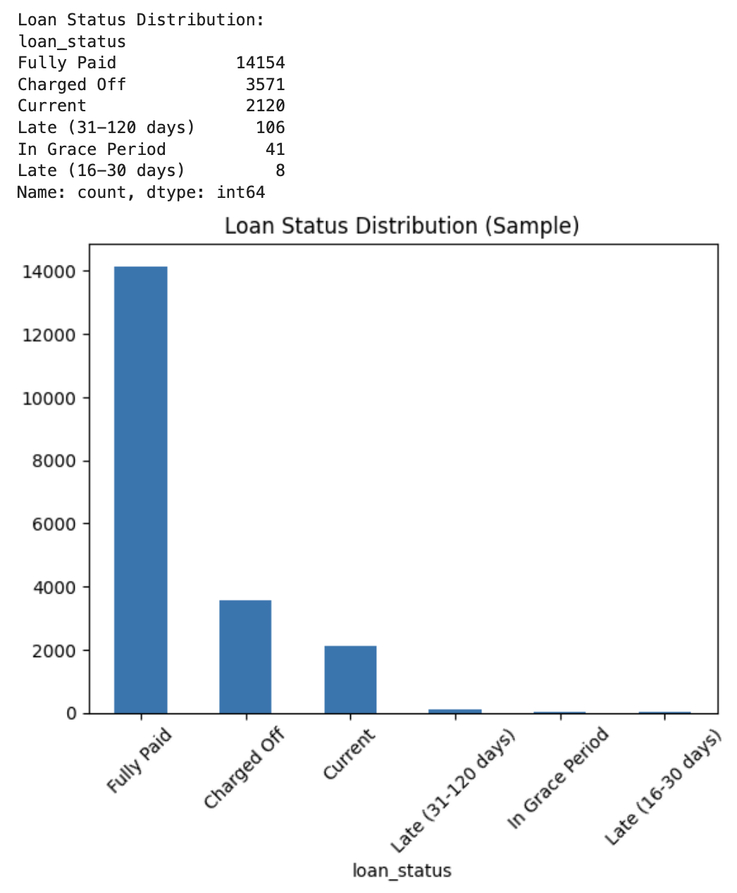

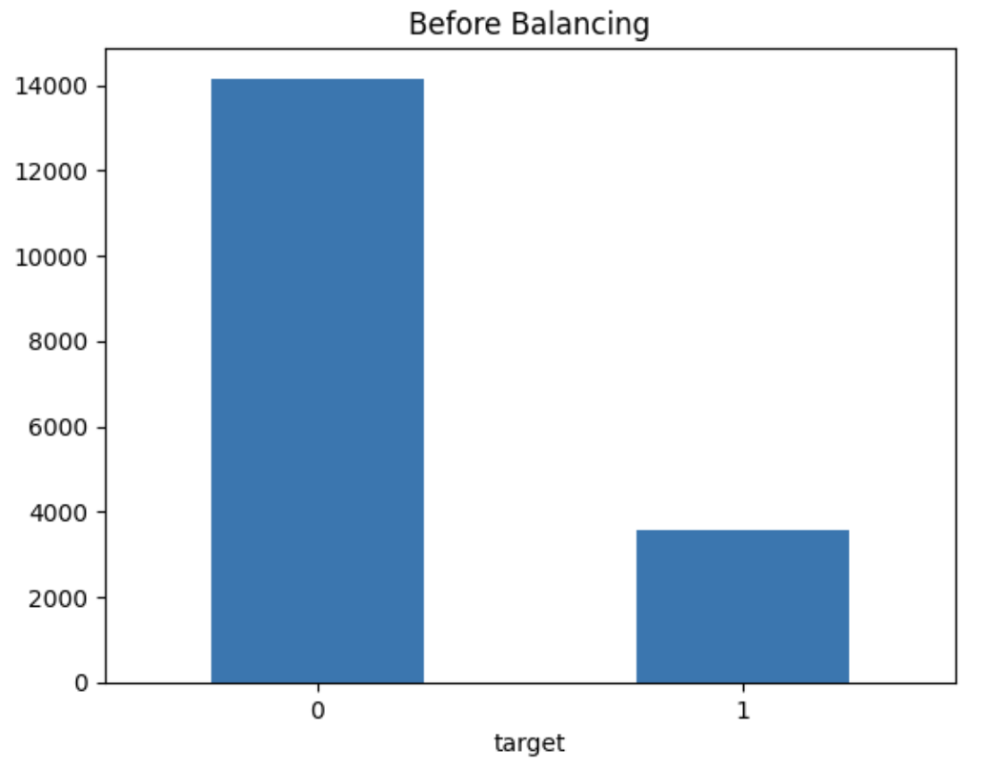

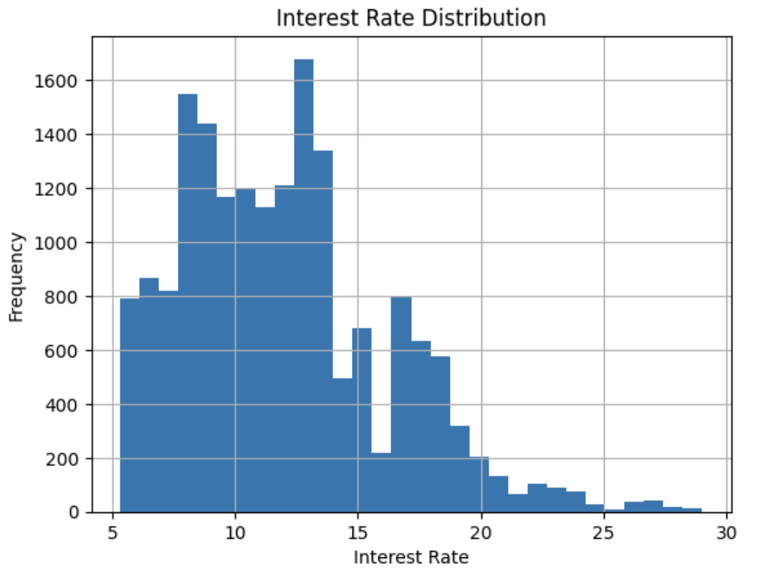

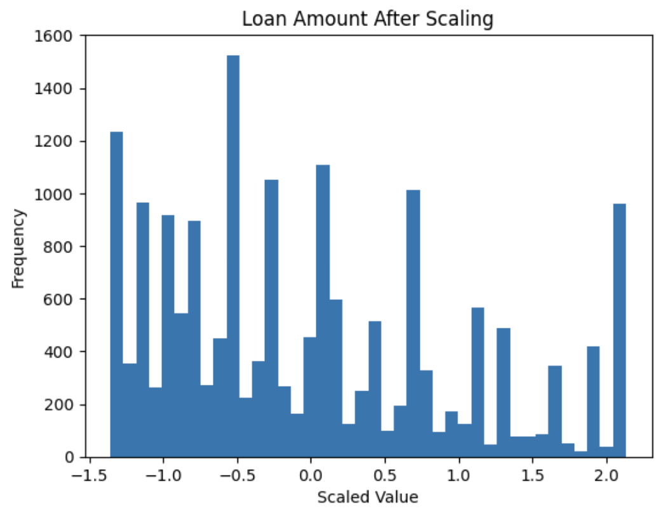

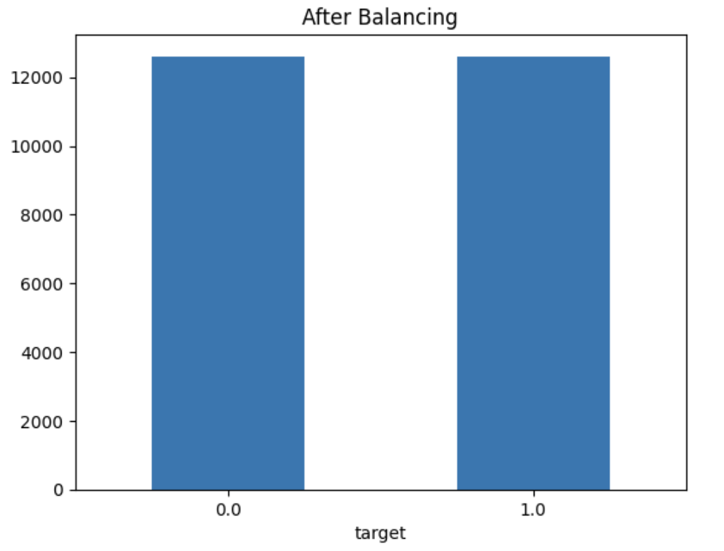

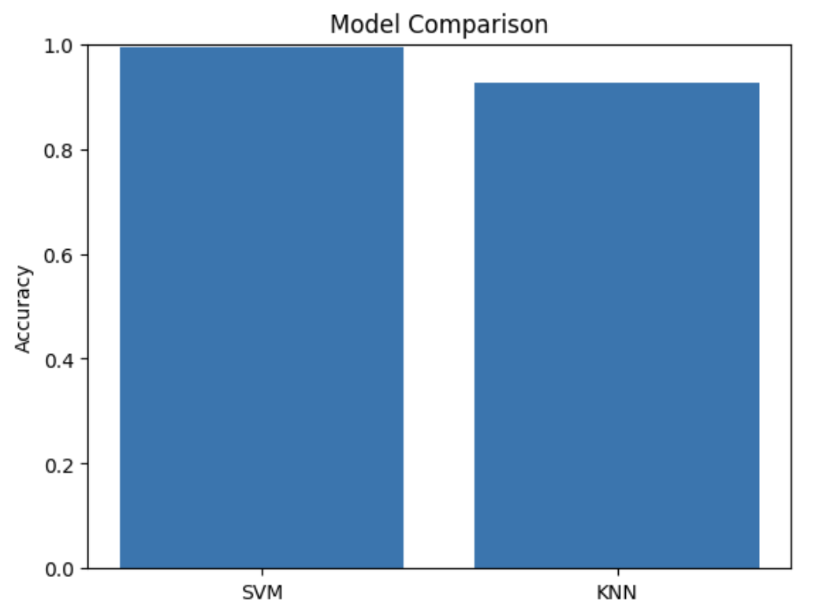

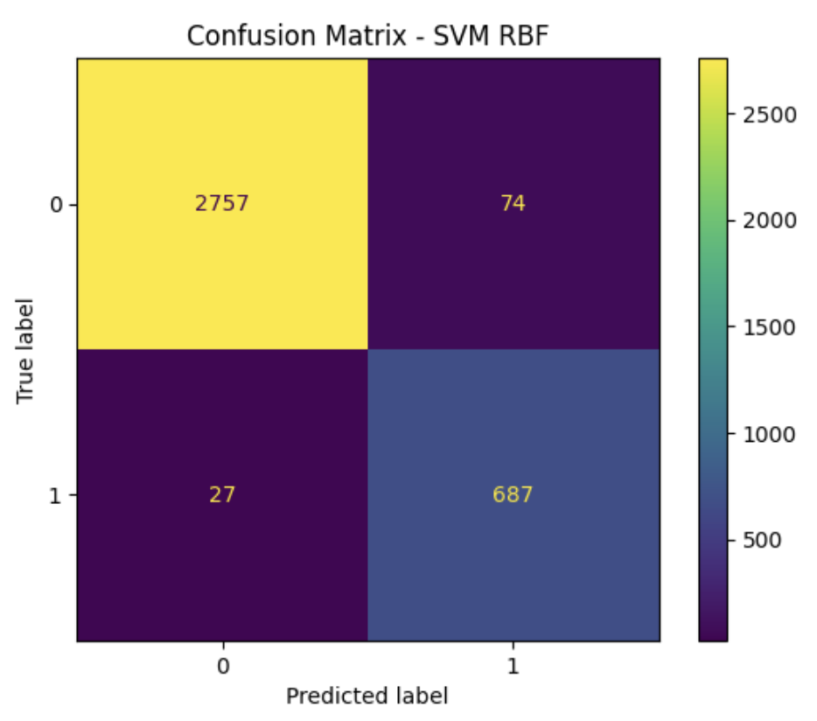

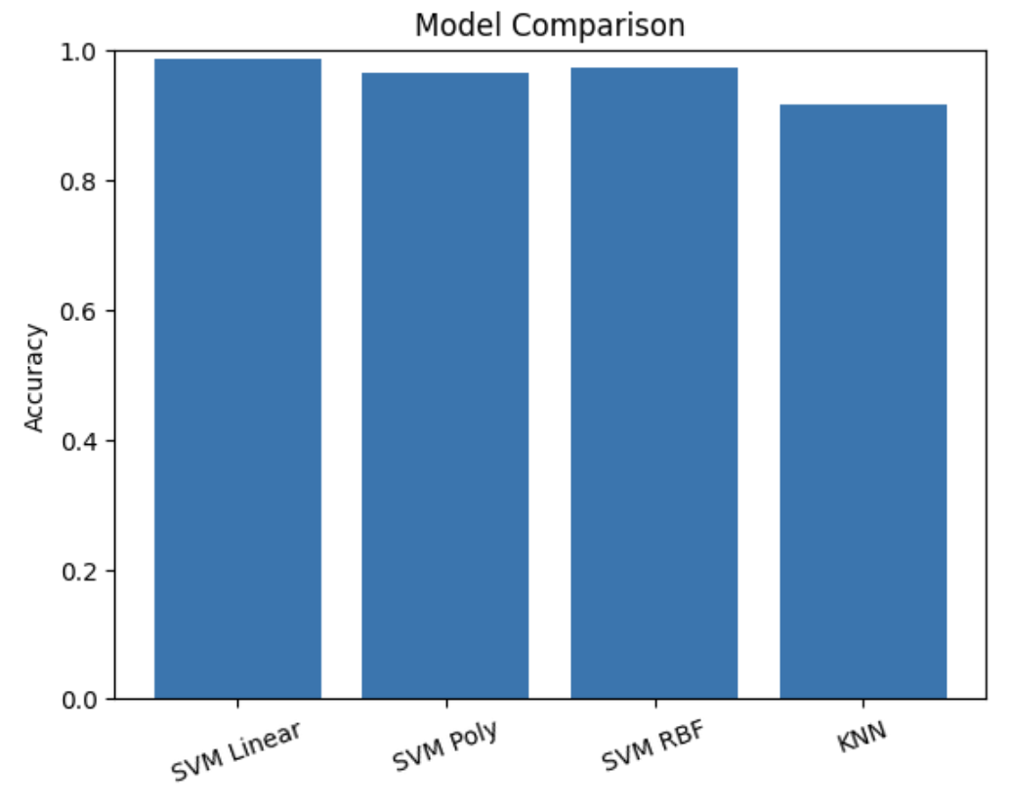

Expected Modules / Libraries to be used
NumPy
Used for numerical calculations and working with arrays efficiently.
Pandas
Used for loading, cleaning, and organizing the dataset.
Matplotlib
Used for creating basic graphs such as histograms and line plots.
Seaborn
Used for advanced visualizations such as heatmaps and boxplots.
Scikit-learn
Used for implementing machine learning models (SVM, KNN), preprocessing, PCA, and evaluation.

Expected Evaluation Metrics and Plots to be used
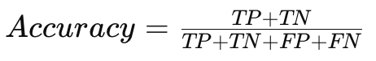
Accuracy
Measures the overall correctness of predictions made by the model.

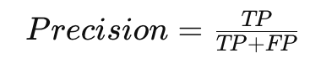
Precision
Measures how many predicted defaulters are actually defaulters.

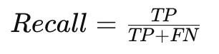
Recall
Measures how many actual defaulters are correctly identified.

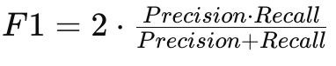
F1-Score
Provides a balance between precision and recall.

ROC-AUC Curve
Shows model performance across different classification thresholds.

Visualization Plots
- Heatmap → To analyze correlation between features
- Histogram → To understand data distribution
- Boxplot → To detect outliers

Required Topics from the Subject
Strings
Used for handling categorical features such as loan purpose and employment type.
File Handling
Used to read dataset files and store processed outputs.

Platform Required
Jupyter Notebook

Books and References
Python for Data Analysis – Wes McKinney
Introduction to Machine Learning – Ethem Alpaydin
https://www.kaggle.com
https://scikit-learn.org

